Mohamed Ahmed Abdelmotaleb Shoaib 18P6395

18p6395@eng.asu.edu.eg

MCT 331 Midterm submission

Assembly Module

Contents

Abstract: - 3 -

Introduction: - 3 -

1. The Cad: - 4 -

2. The Matlab: - 6 -

3. The Simulink Circuit: - 7 -

4. The Contacts: - 8 -

5. The Signals: - 12 -

6. Actuator Sizing - 14 -

# Abstract:

By talking about complex systems, systems engineering is always named as the only  
way out for the enhancement of system understanding and the reduction of system  
complexity in the design process. After an identification of the essential aspects and  
concepts for pursuing systems engineering. A standardization for the development process  
of the mechatronics system is VDI 2206.

The main purpose of matlab simulation to try to make the system working and reliable without making a prototype of the project and cost money in real big project. The matlab helped us to see each module working.

# Introduction:

The assembly module is responsible to put the 2 parts on each other. I used 2 four mechanism, the first one is moving the suction cup up and down, the second one is to fix the suction cup holder in its position so we can press the suction cup.

# The Cad:

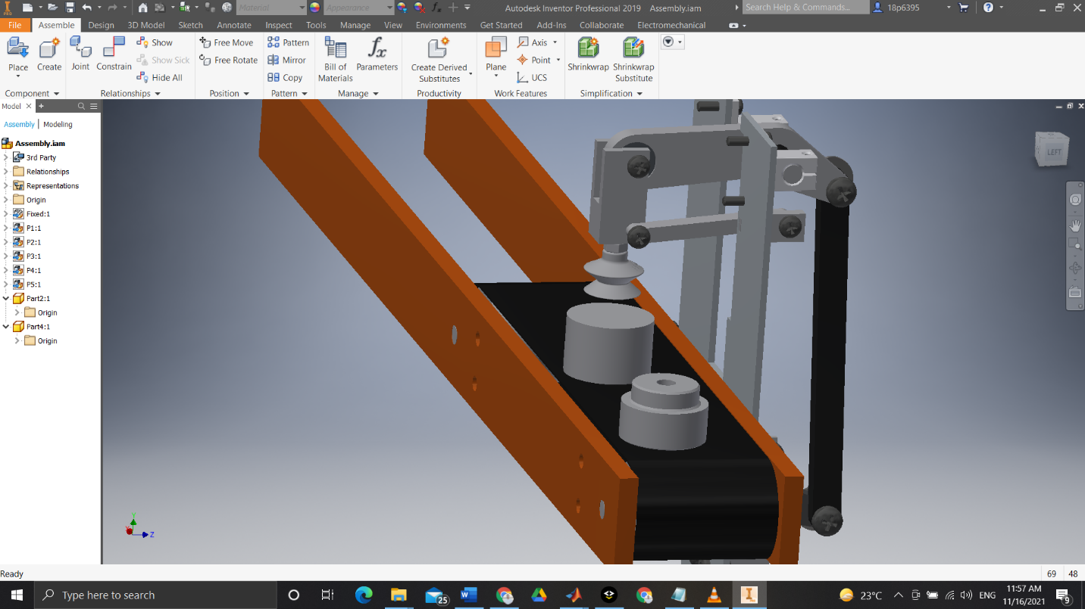

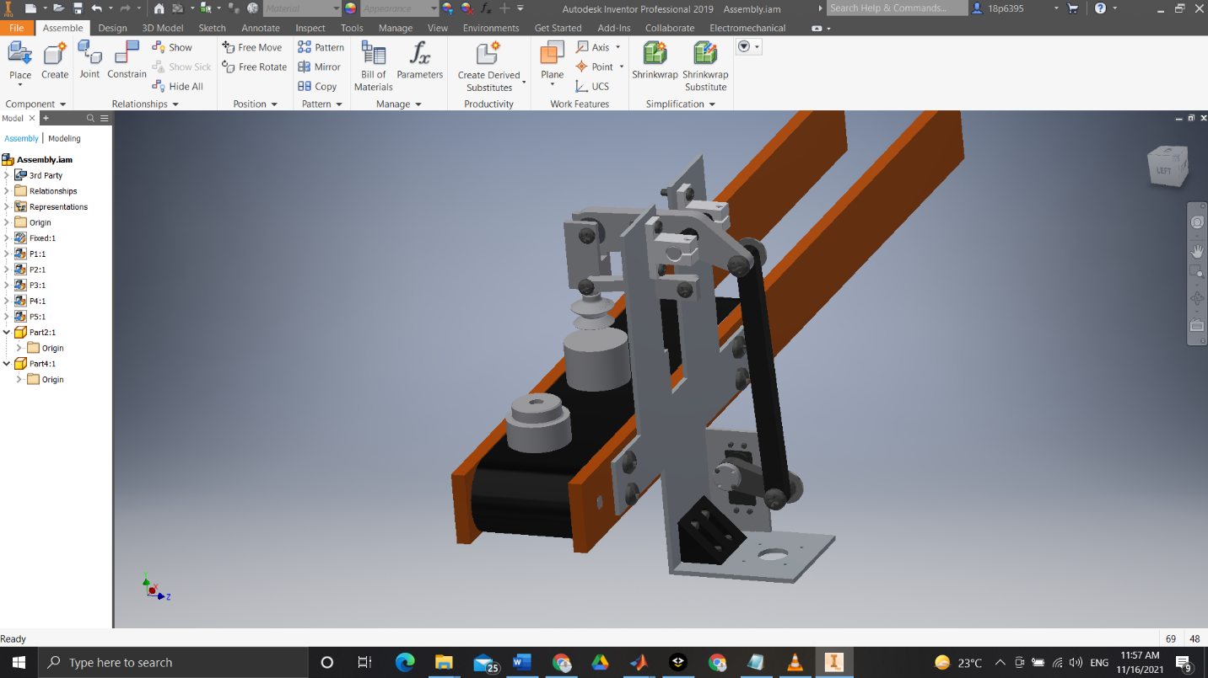

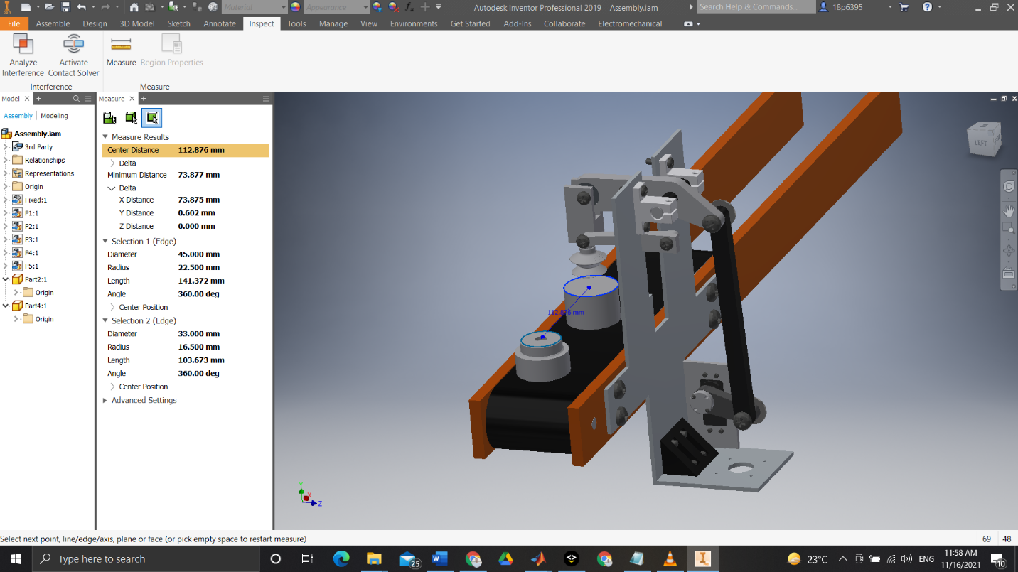



The distance between the 2 parts is about 113 mm will be used in the matlab, and the are concentric with the suction cup.

# The Matlab:

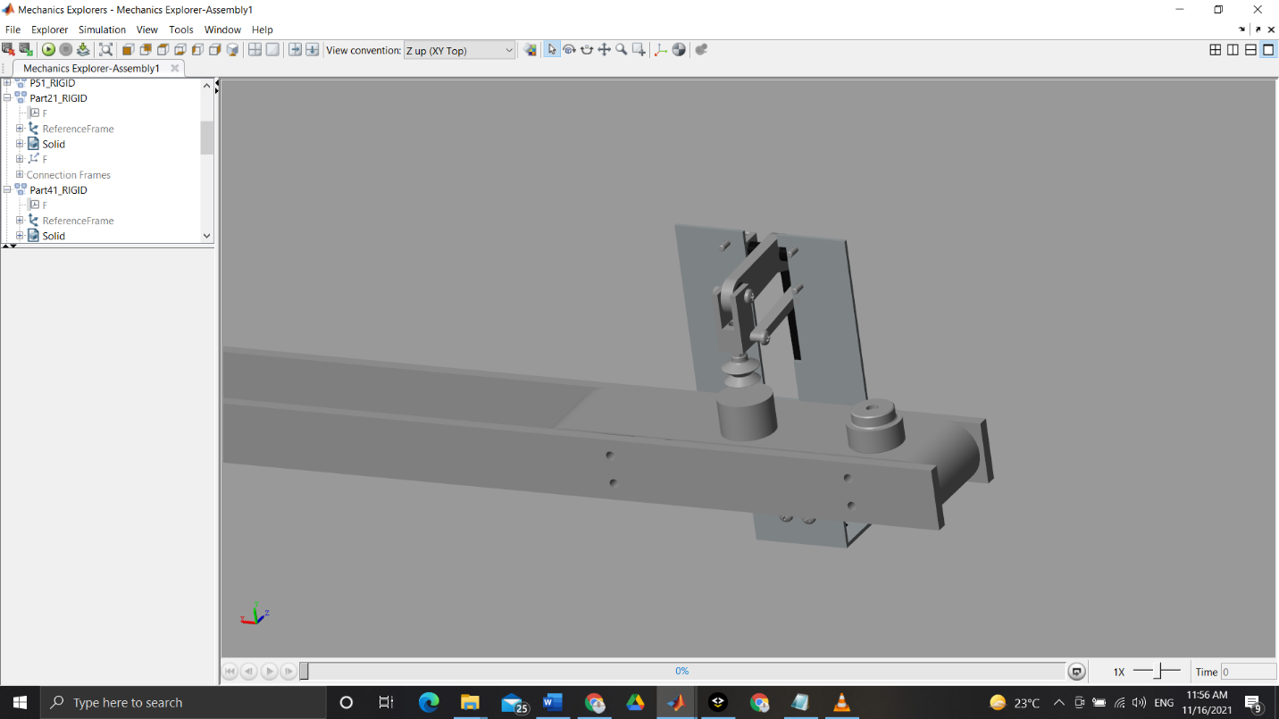

Video for the whole module working:

<https://drive.google.com/file/d/1HVslpROE1Dep3GdlN3tZtgvX7XqWqQHC/view?usp=sharing>

# The Simulink Circuit:

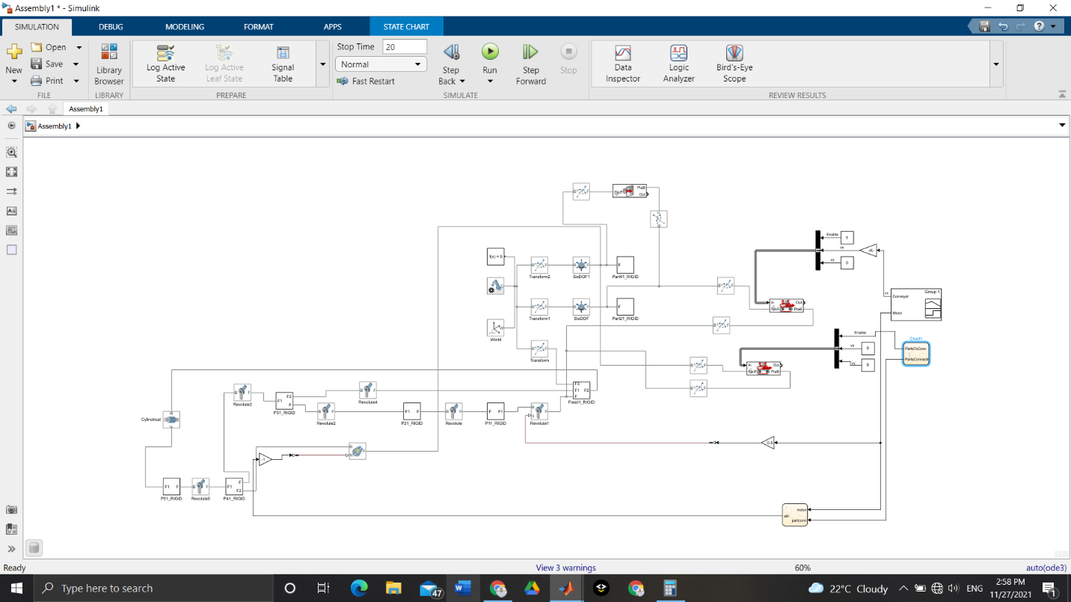

# The Contacts:

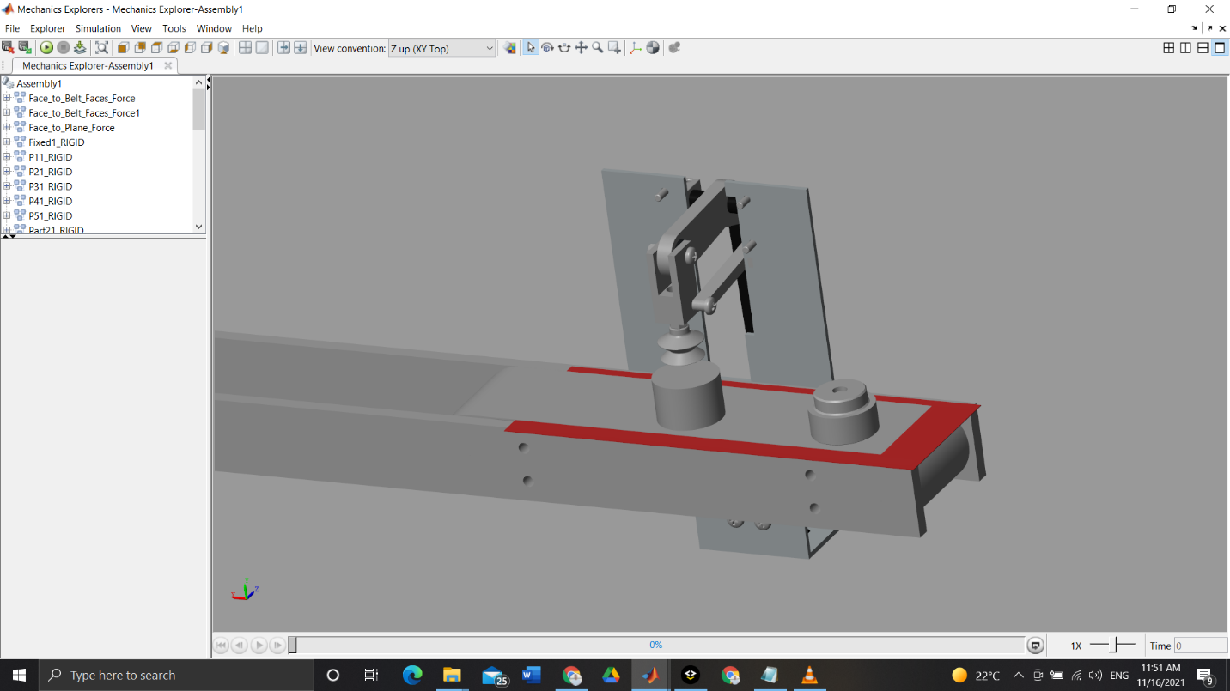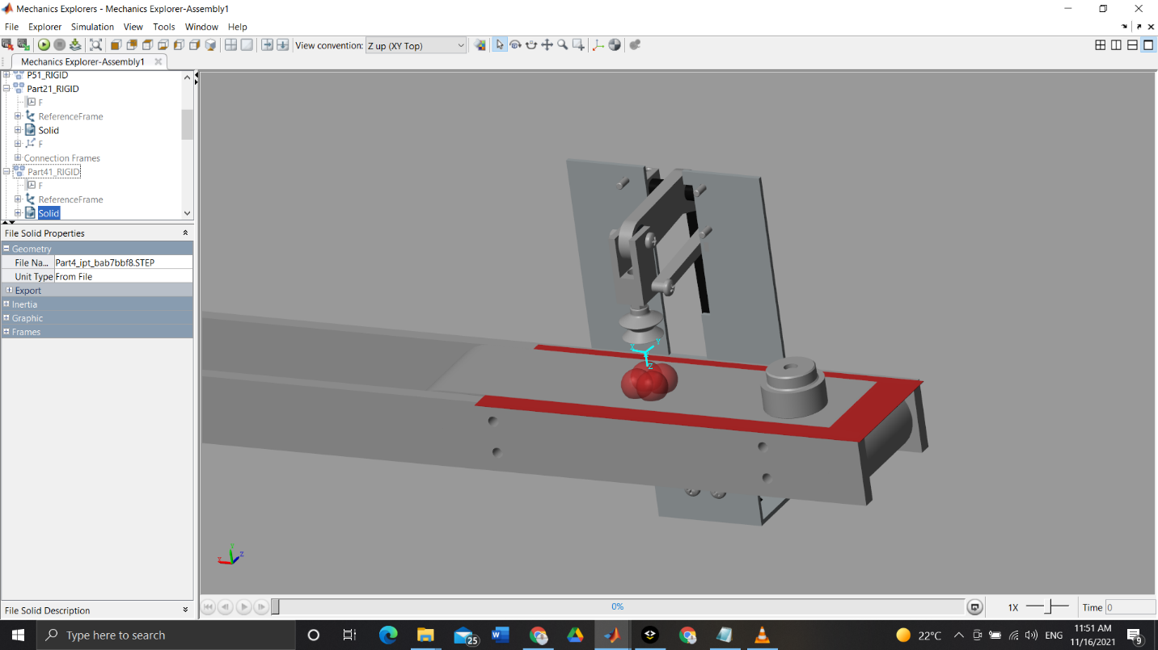

First part with the conveyer

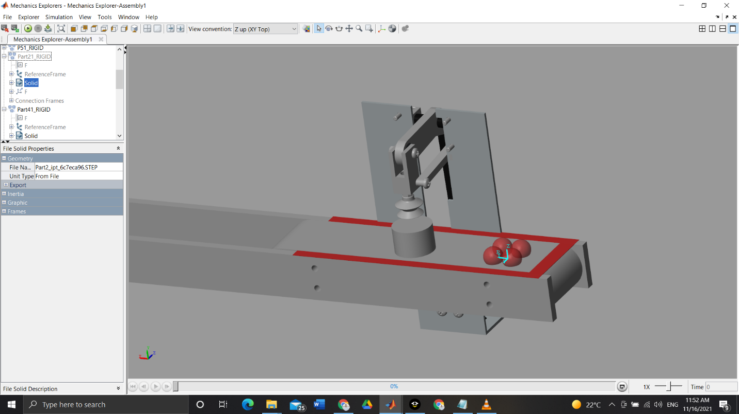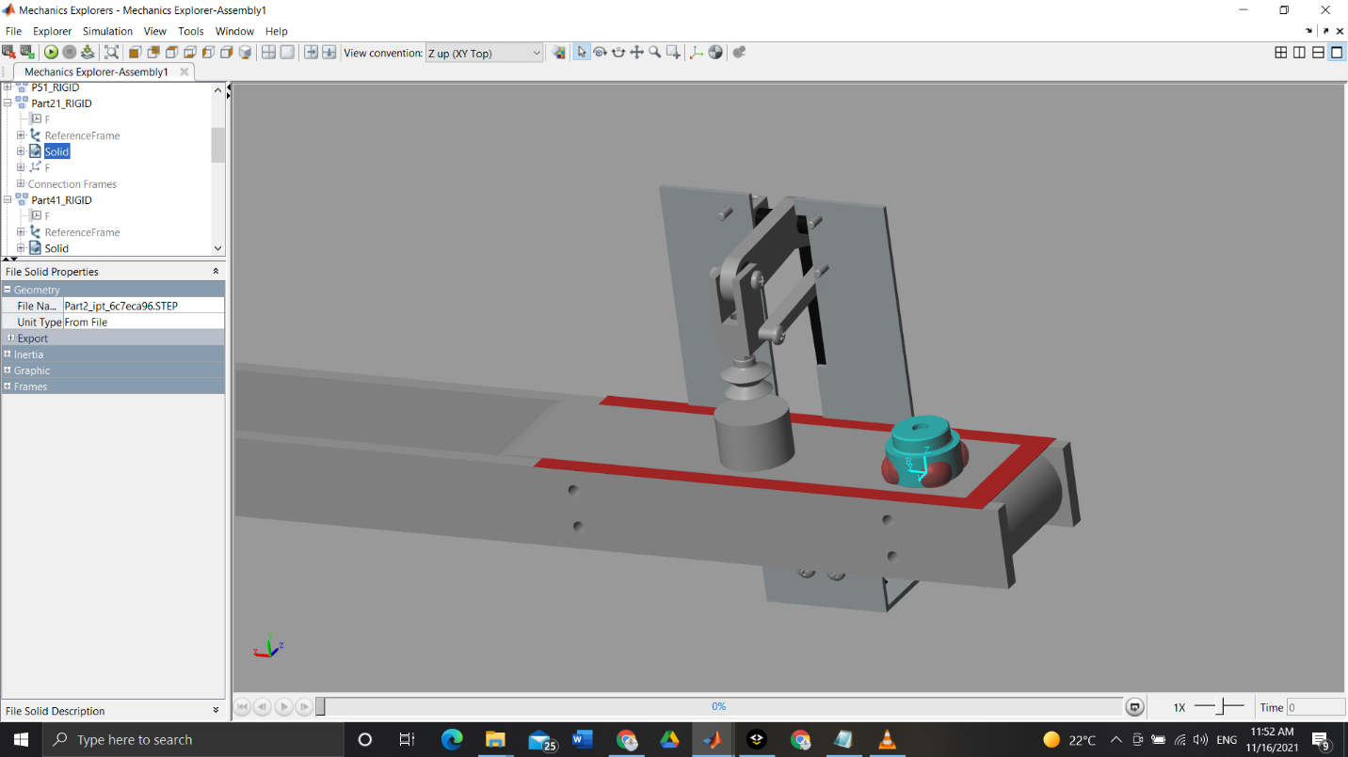

Second part with the conveyer

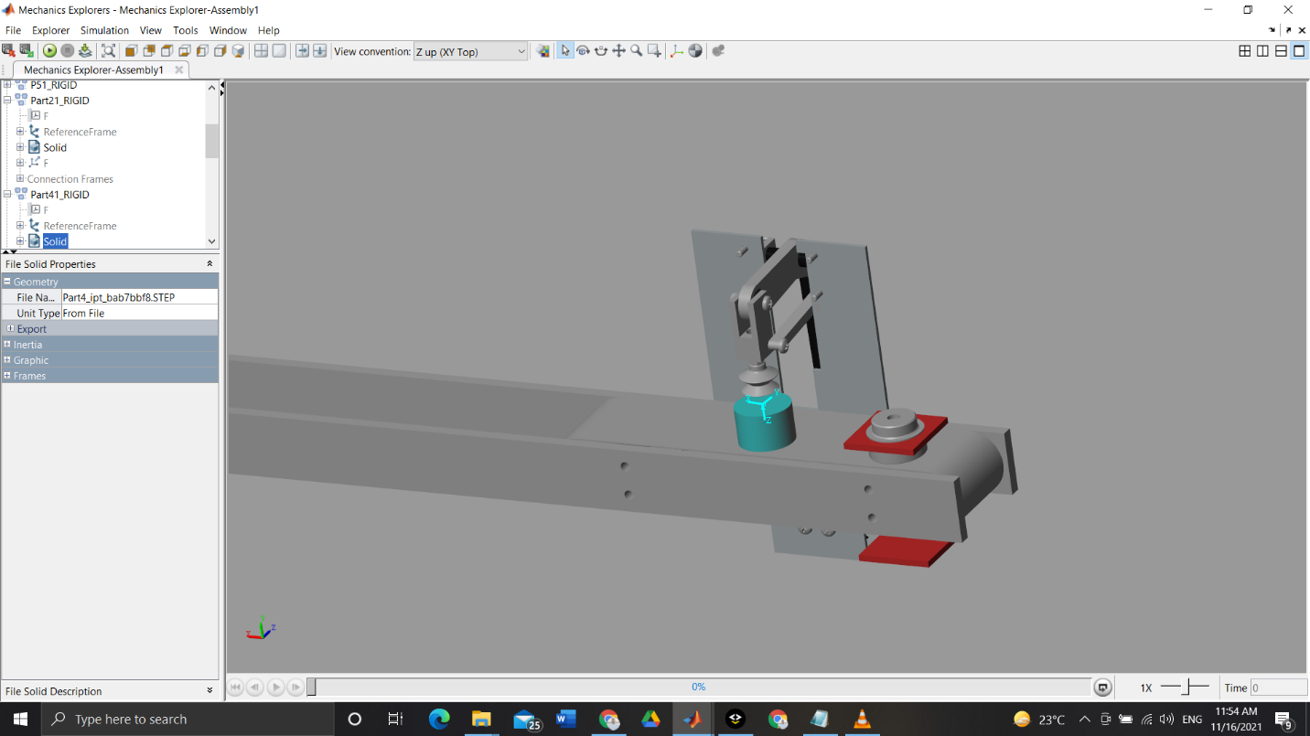

The 2 parts together with face to plane.

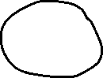

The suction cup attraction to the first part and control by state flow.

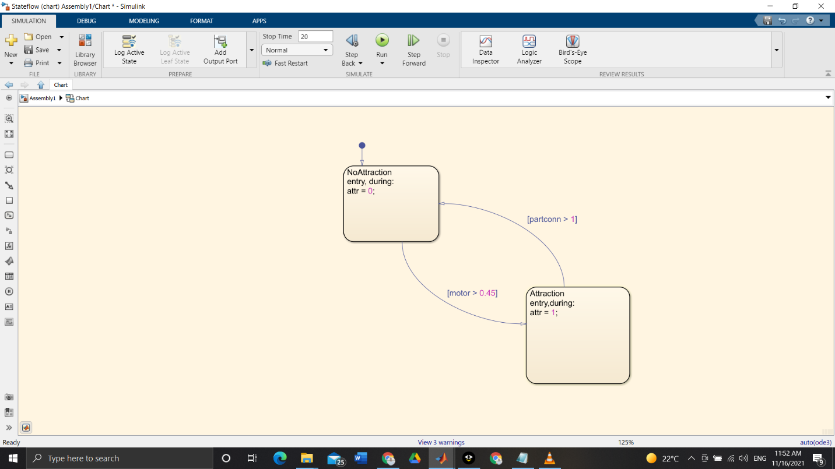

The state flow controlling the suction cup. 2 inputs: motor signal and parts connection.

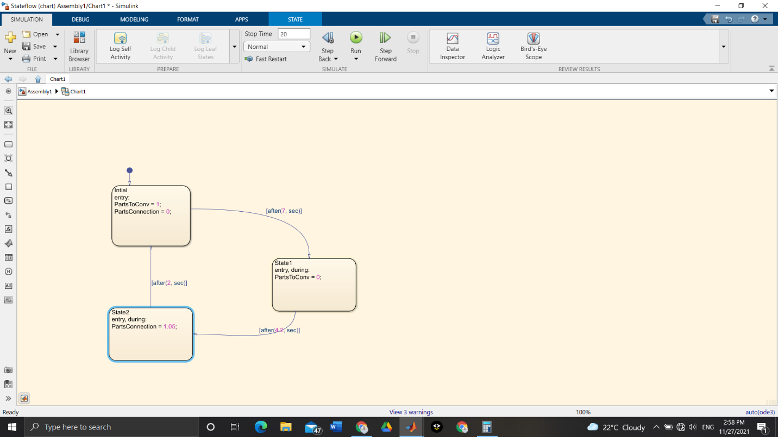

The state flow controlling the face to belt contacts of the parts between each other and the first part to the conveyer.

# The Signals:

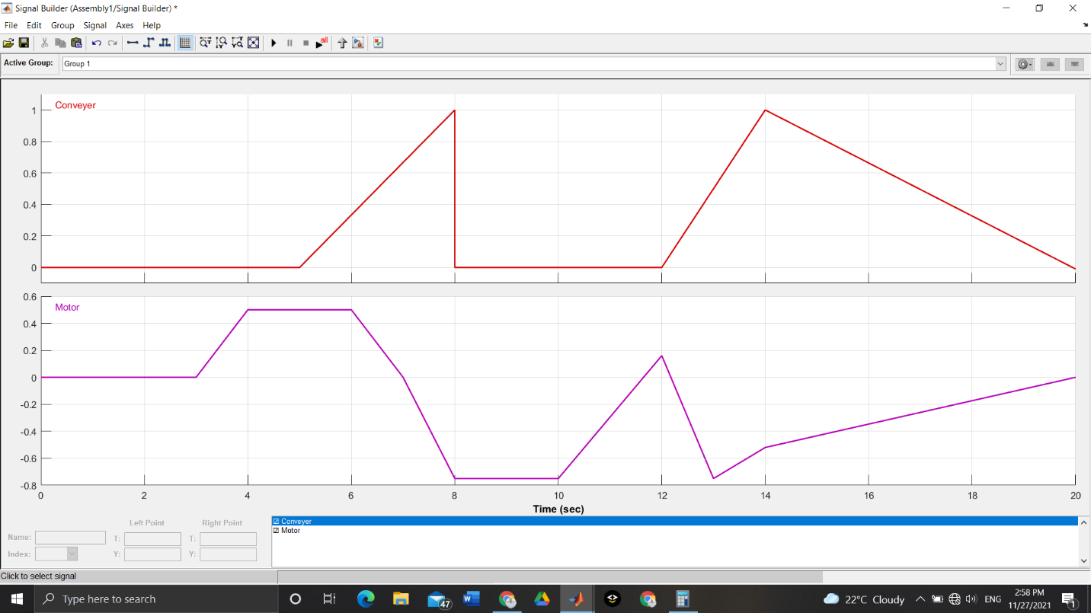

2 signals controlling: conveyer, motor.

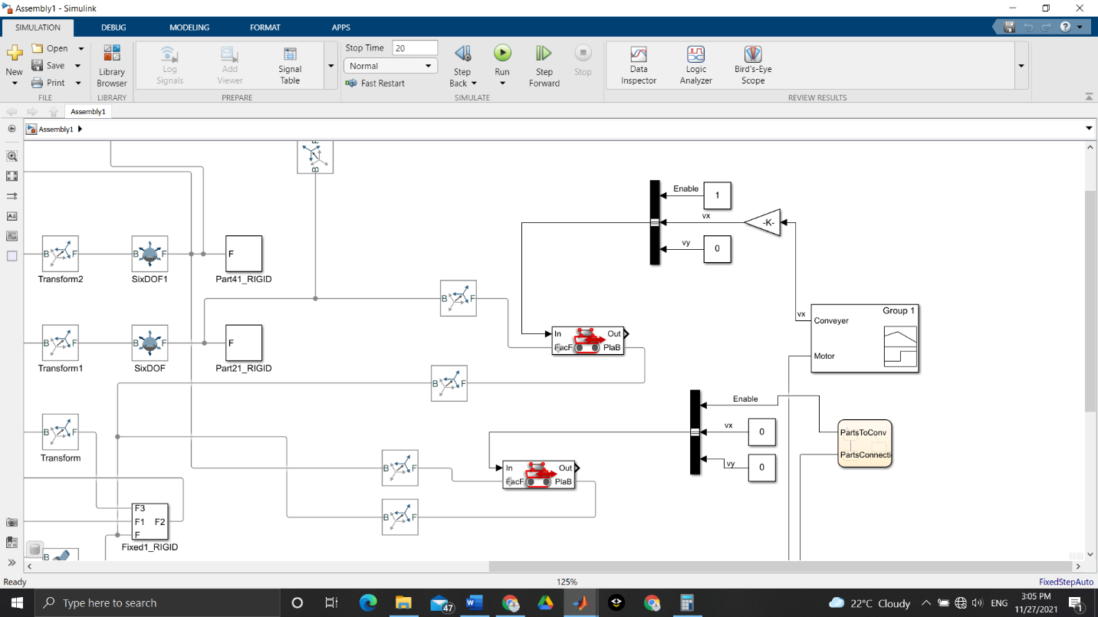

Connection of the signal converter and the face to belt to control it, the upper one are always enabled but the second one is for the part being held up with the suction cup, so it unenabled after the part is held up.

# Actuator Sizing

